**Step 1:**

Write Python Code with the comments as format of Sphinx – Example is

|  |
| --- |
| class AClass:  """  Class docstring, with reference to the :mod:`module`, or another class  :class:`module.AnotherClass` and its function :func:`module.AnotherClass.foo`.  """    def foo(arg1, arg2):  """  A method's docstring with parameters and return value.    Use all the cool Sphinx capabilities in this description, e.g. to give  usage examples ...    :Example:    >>> another_class.foo('', AClass())    :param arg1: first argument  :type arg1: string  :param arg2: second argument  :type arg2: :class:`module.AClass`  :return: something  :rtype: string  :raises: TypeError  """    return '' + 1 |

**Step 2:** Install Sphinx in Python using PIP

|  |
| --- |
| pip install Sphinx |

**Step 3:** Execute Command in CMD

|  |
| --- |
| sphinx-quickstart docs |

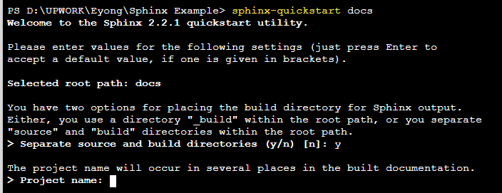

Enter name of project, author name etc.

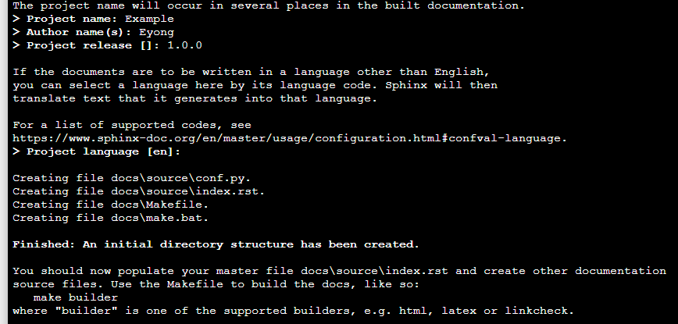

Now check you will have folders and files created in the directory

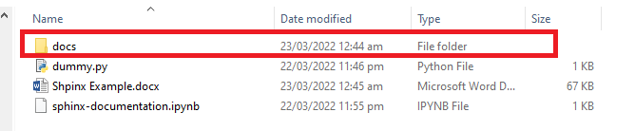

Inside Doc

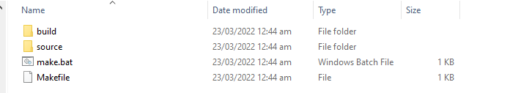

Inside Source you will have

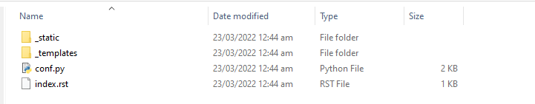

Now copy that python file created at the start “dummy” here

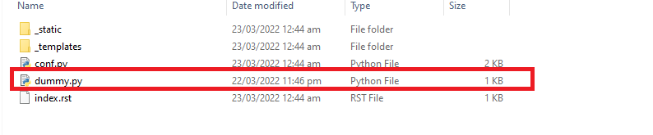

Now open conf.py file and make changes – uncomment these lines

|  |
| --- |
| import os  import sys  sys.path.insert(0, os.path.abspath('.'))  and also add this line  extensions = [  "sphinx.ext.autodoc",  ] |

Save and close that file

Now open index.rst and add your code file name as shown

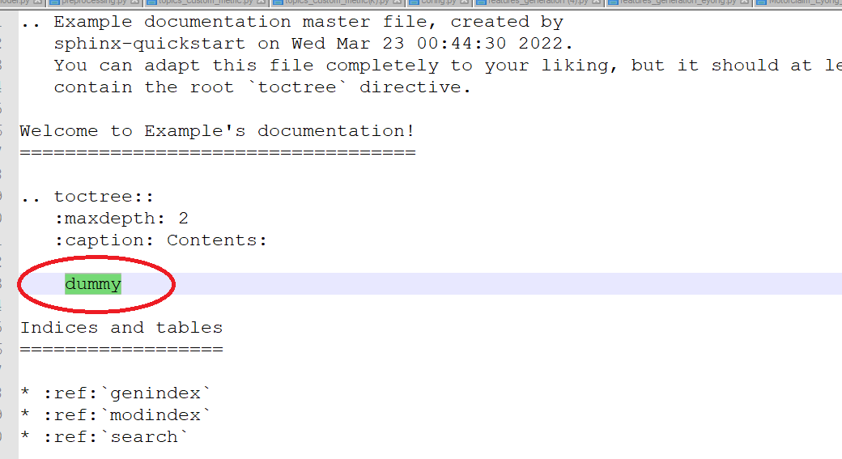

Save and Close

Now go to source folder using command cd

|  |
| --- |
| cd docs/source |

Now execute following command

|  |
| --- |
| sphinx-apidoc -o . . |

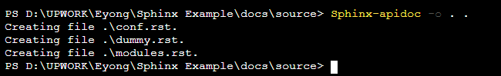

For all your python files, you will see RST files

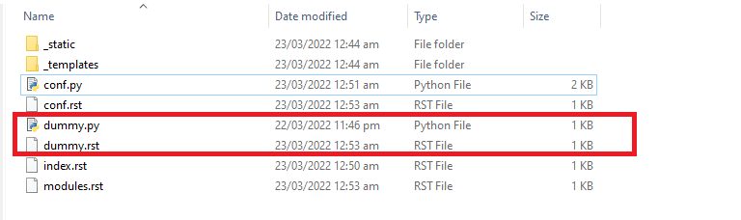

Now execute cd..

Cd..

Go to main directory and execute following command

|  |
| --- |
| sphinx-build -b html docs/source/ docs/build/html |

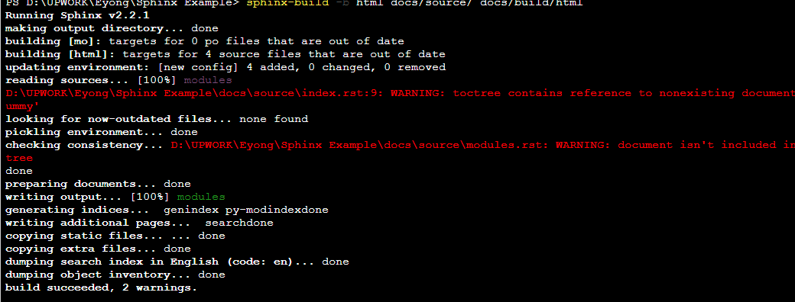

Now go to following folder you will index.html file

Double click and open that file

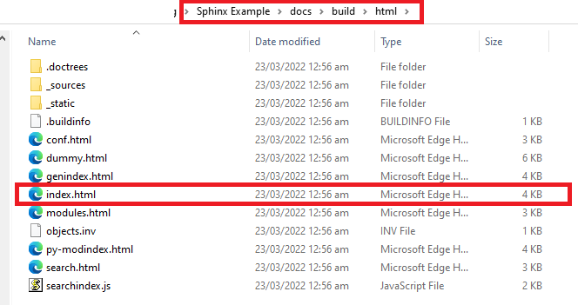

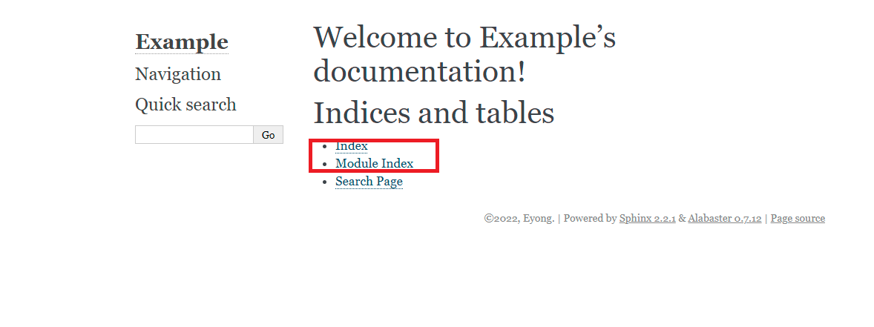

Click on modules

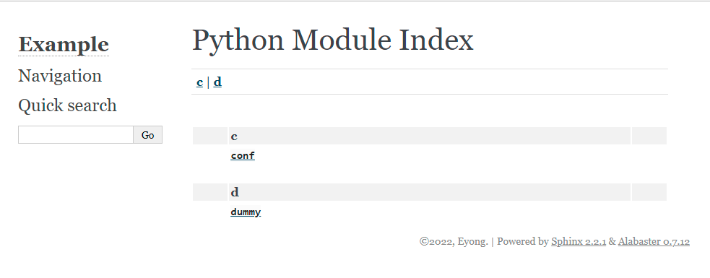

Click on your module dummy

You will see your documentation

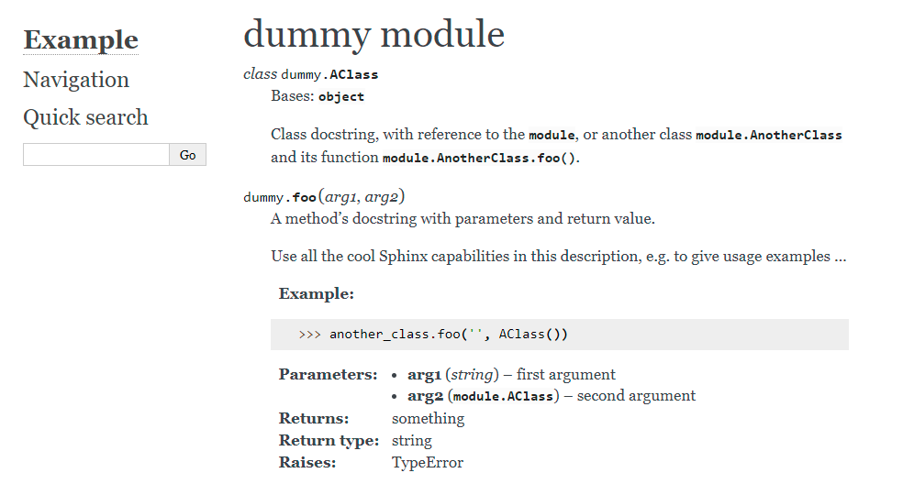

If you add

"sphinx.ext.viewcode",

To conf.py file then you will have

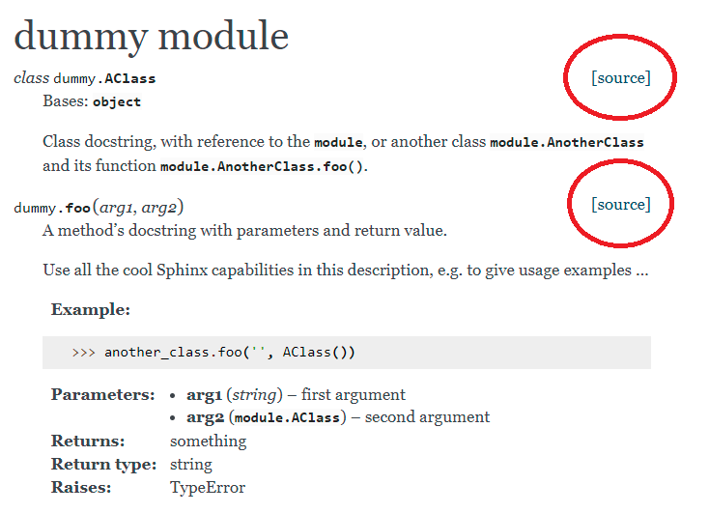

On clicking source it will show complete source code

